Ex.No:4a Installation of Citrix XenServer
Date:

Aim:
To install and configure Citrix XenServer for virtualization of multiple operating systems , use XenCenter for graphical management of virtual machines and perform live migration of VMs between physical hosts without downtime.
Procedure
Citrix XenServer is a virtualization platform based on the open-source Xen Hypervisor. It enables efficient creation, management, and execution of multiple virtual machines (VMs) on a single physical host.
Installation Steps:
- Download ISO:
  - Get the official XenServer ISO from Citrix website.
- Boot and Install:
  - Insert the USB and boot the server.
  - Follow the on-screen instructions:
    - Select installation drive (e.g., local disk).
    - Configure network settings (static IP recommended).
    - Set root password.
    - Choose to install XenServer tools
- Complete Installation:
  - Reboot system after installation.
  - XenServer boots with a console UI showing IP address and system info.
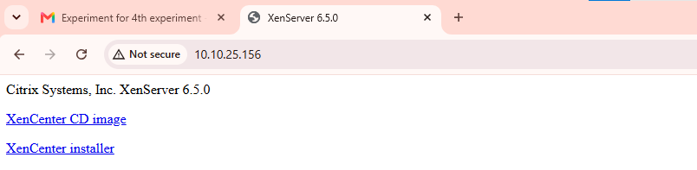
Result
Thus, the installation of and configuration of xenserver has been completed.
Ex.no: 4b Live Migration of Virtual Machines using Xen Center
Date:

Live Migration of Virtual Machines using XenCenter
Live Migration refers to moving a running virtual machine from one physical host to another without shutting it down, using XenCenter’s GUI.

Steps 1:
Add the new server by clicking the server in the xencenter and server-> Add

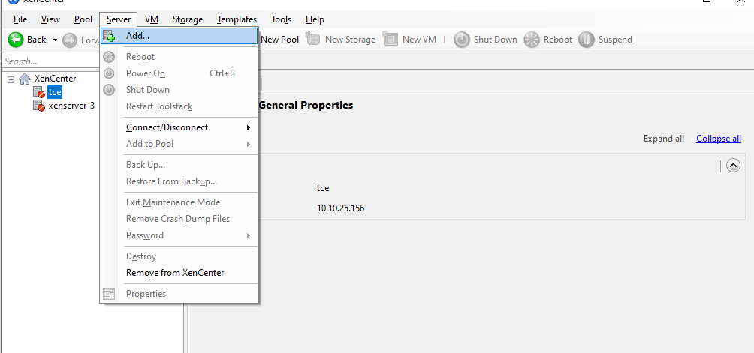

Steps 2:
Add the xenserver 1 by entering the Server , Username and password and click add.
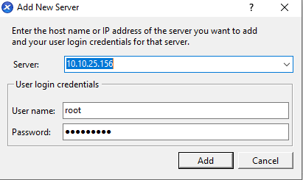
Steps 3:
Next add the vm of yours by clicking the xenserver 1 (right click) and add click new vm
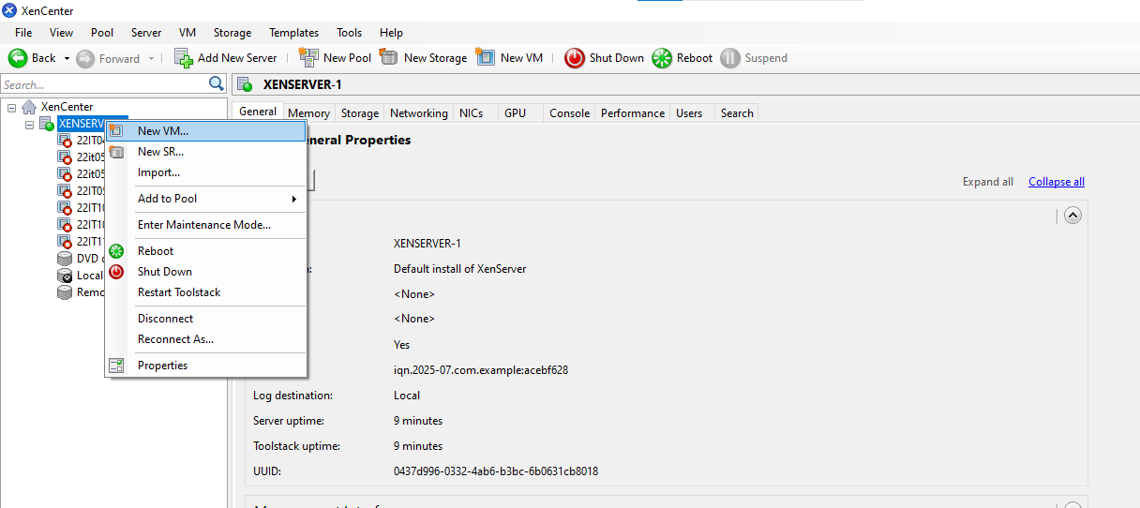

Steps 4:
Click the template example citric or ubunttuos or cent os(os which you have).
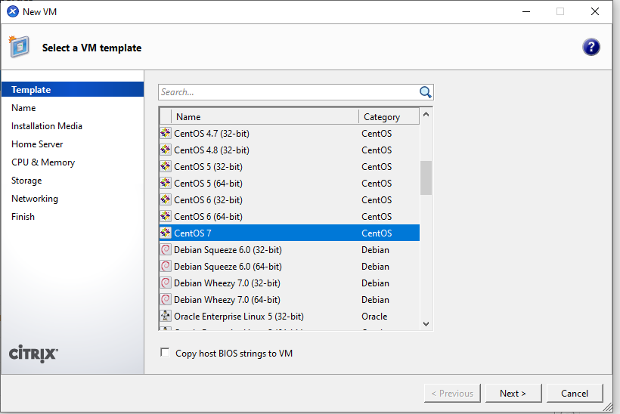

Steps 5: Give the name for your Vm and click next.
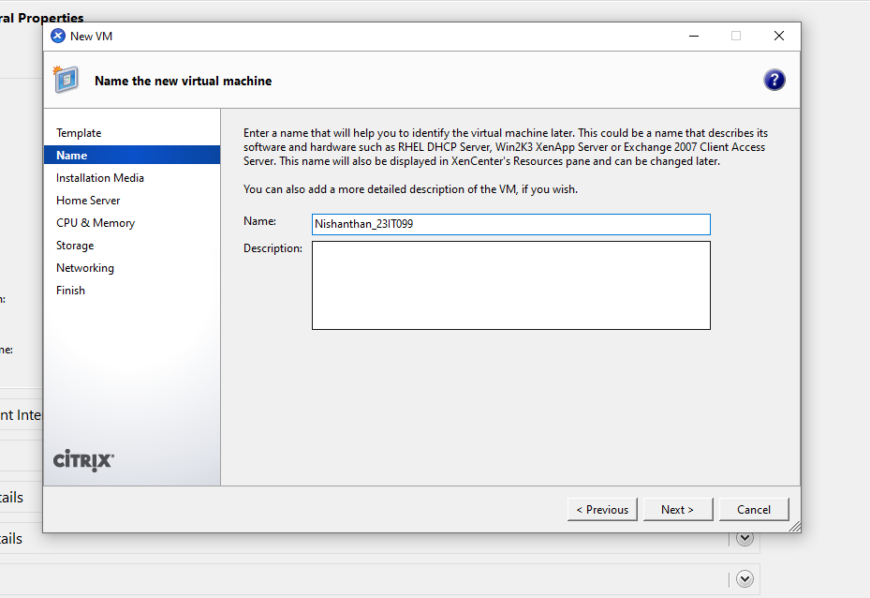

Steps 6: Select the iso file inside and click the next
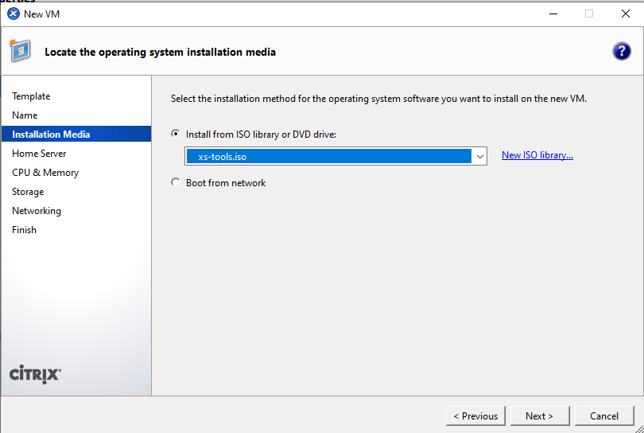

Steps 7:
Finally click the create now option then your vm has been created successfully.
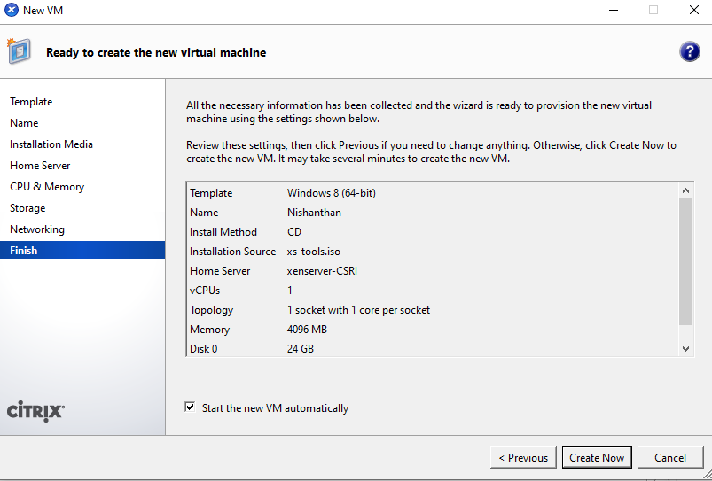
Steps 8: Create a xenserver 2 same procedure followed in first xenserver1 and click the xenserver 1.
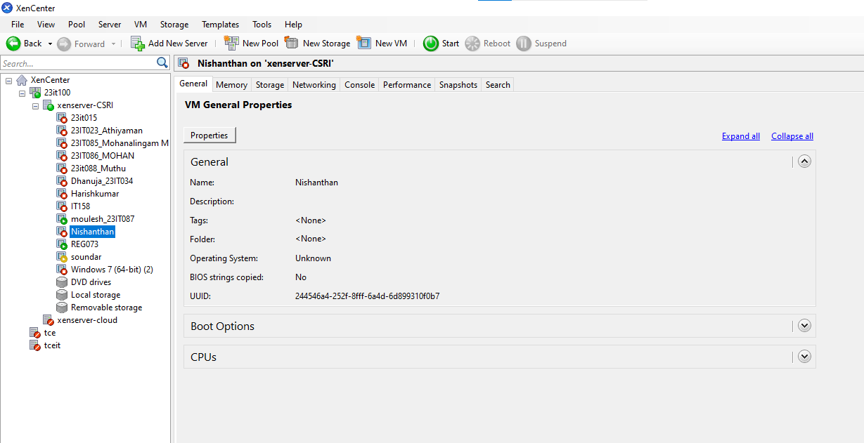

Steps 9:
Right click the vm and select the move vm option from the following
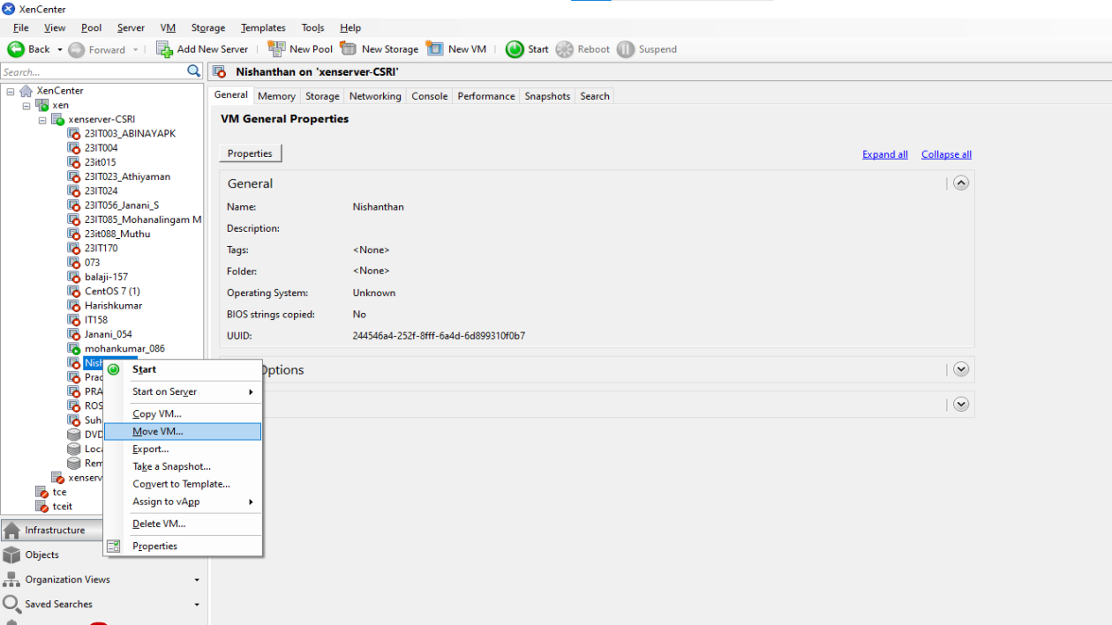

Steps 10: Select the xenserver 2 from the following list
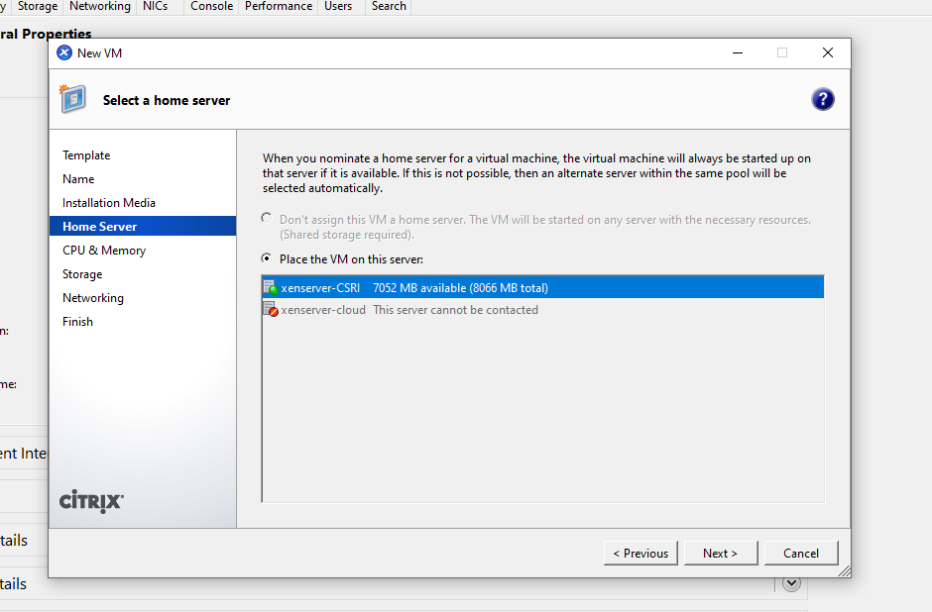

Steps 11:
Now see the Vm in the second servertce and the live migration has been executed successfully.
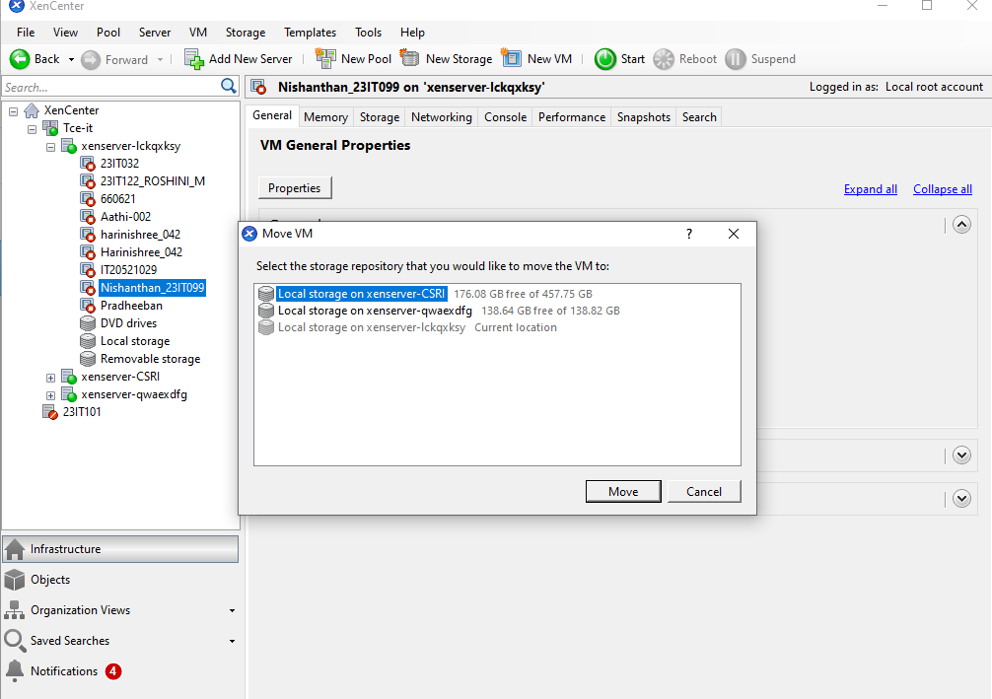
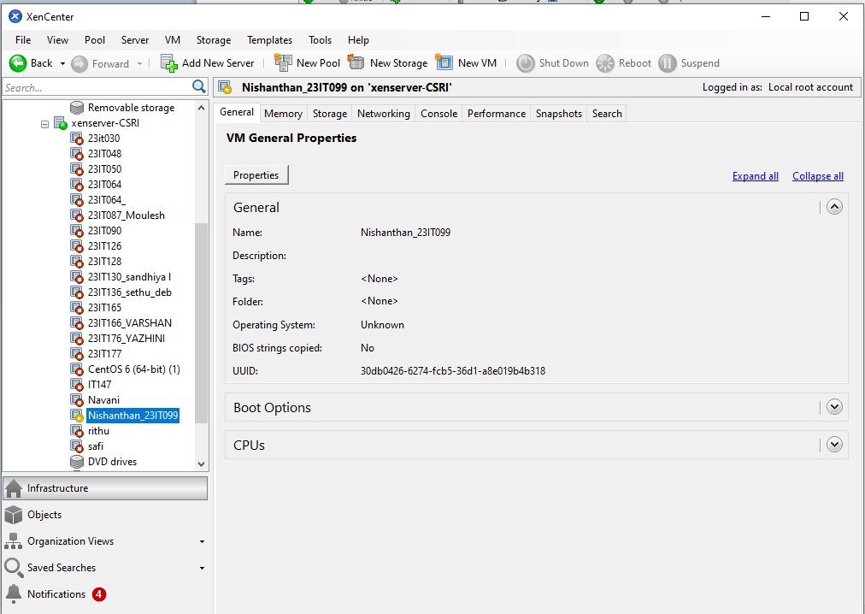

RESULT:
Successfully executed the setup of XenServer and XenCenter; live migration was performed and output verified with zero downtime during VM transfer.

